- Install IIS Web Server with all required features and management tools.
  - Start Server Manager, run Add roles and features wizard and install following:
Roles:
- Web Server IIS
Web Server IIS Role features and services:
- Web Server -> Security -> Windows Authentication
- Web Server -> Application Development -> ASP.NET 4.6
- Setup Web Site
  - Create Folder c:\inetpub\AMS
  - Copy Application files to c:\inetpub\AMS
  - Open IIS management console. Select Server.
  - Create Web Site. In IIS Management Console right click on Sites -> Add Website…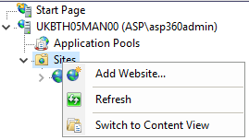
  - Fill fields as shown:
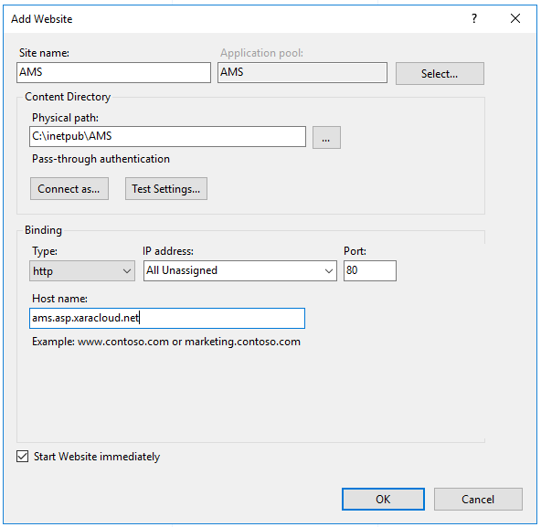
  - Setup Web Site Authentication. Select site AMS.
- Double click Authentication icon.
- Disable all Authentication except Windows Authentication.
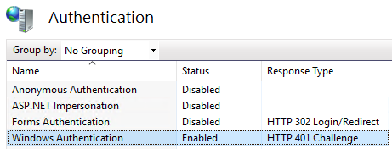

- Right Click Windows Authentication -> Providers
- Remove all providers and add Negotiate:Kerberos. Click OK.
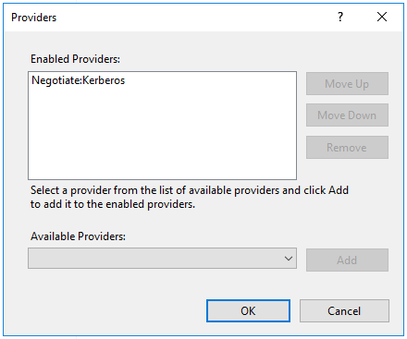
- Right Click Windows Authentication -> Advanced Settings…
- Untick Enable Kernel-mode authentication.
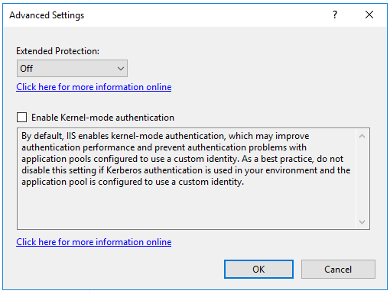

  - Disable Default Web Site. Right click on it -> Manage Web Site -> Stop
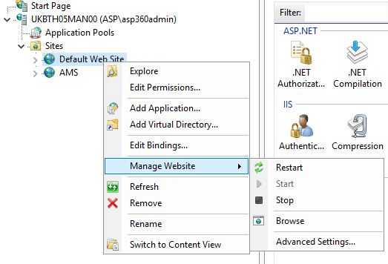
  - Setup Application Pool. Click Applications Pools and right click AMS pool -> Advanced Settings
- Check that Managed Pipeline Mode is Integrated
- Check that .NET CLR Version is 4.0
- Change Start Mode to Always Running
- Change Pool Identity to LocalSystem
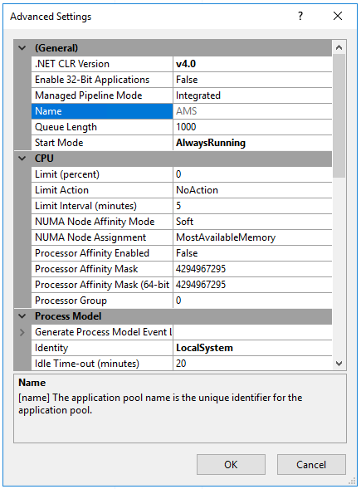
  - Change Windows Authentication Settings for AMS Web Site. Select AMS site in left pane and double click Configuration Editor. 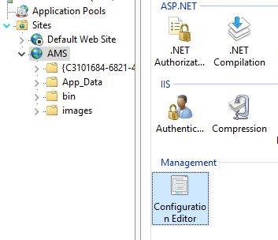
In dropdown tree menu select system.webServer -> security -> authentication -> windowsAuthentication
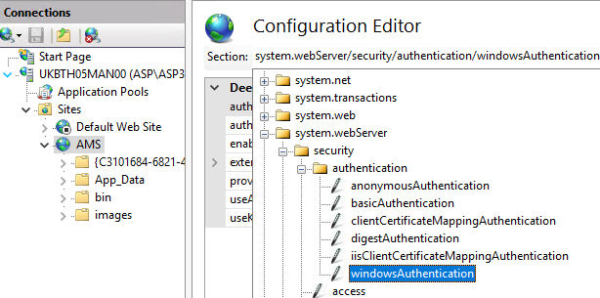
Setup parameters as shown:
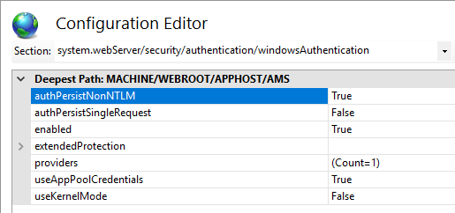

And сlick Apply on the right pane.

  - Disable all other pools. Right click on pool -> Stop.

- Setup Kerberos Authentication
  - Create SPN for web server account. Open cmd as user that has write access to web server AD account and run command:
setspn -s HTTP/_service_URL_ _WEBSERVER_HOSTNAME_
For example if service URL – ams.asp.xaracloud.net and Web Server Host Name – ukbth05man00:
setspn -s HTTP/ams.asp.xaracloud.net ukbth05man00
Check that SPN created successfully:
C:\Users\asp360admin>setspn -l ukbth05man00
Registered ServicePrincipalNames for CN=UKBTH05MAN00,OU=Management Servers,OU=Member Servers,DC=asp,DC=xaracloud,DC=net:
HTTP/ams.asp.xaracloud.net
3.2 Enable Delegation for Web Server AD Account.
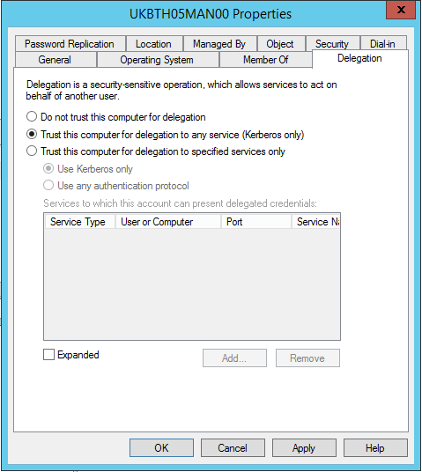
- Create task in Windows Task Scheduler
  - Start Windows Task Scheduler, right click on Task Scheduler Library -> Create Task…
  - Enter task Name and Description. On Security Options pane tick Run whether user is logged on or not.
  - Click Change User or Group… button and select AD account to run task. All created tasks will run as selected AD account. So, this account must have necessary permissions in AD, DFS shares and Exchange Server. 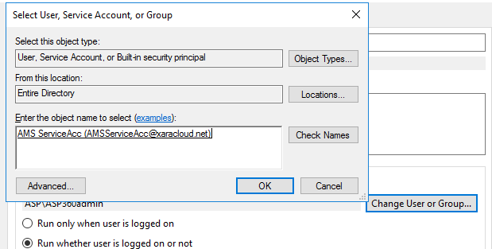
  - Click Triggers tab. Create new trigger. Tick Repeat task every: and select desired time interval (1 hour). Select for a duration of: Indefinitely. Tick Stop task if it runt longer than and select time interval (1 hour). 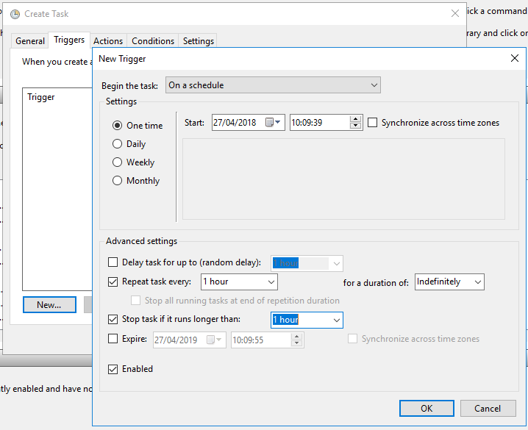
  - Click Actions tab and create Action Start a program.
Program/Script:
powershell.exe
Add arguments (optional):
Invoke-WebRequest -Uri 'http://ams.asp.xaracloud.net/tasks.aspx?StartTasks=true' -Method GET -UseDefaultCredentials
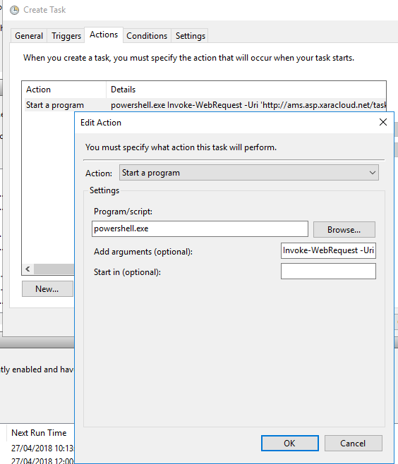

Click OK in Edit Action window.
  - Click OK in Create task window and enter account password. If message about required permissions for selected account appears (for example – Log on as batch job), then open Local Security Policy management tool and grant required rights. 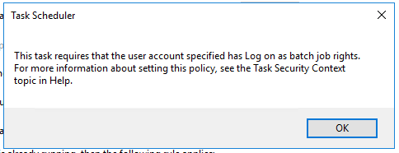
- Install Powershell Modules.
Run powershell with admin privileges and execute:
Install-Module -Name PSAlphaFS

- Add users of the service to management servers built in Remote Management Users group.

