Upgrade Guide can help you in reflashing your device based on Amlogic S905 S805 SoC
Thanks for materials and answering questions to Ugoos Blog and ChinaGadgetReviews
What you need:
Image file
Host PC
USB OTG Cable
TF Card (Micro SD or SD)
USB_Burning_Tool_v2.0.5.15 (maybe another v)
Supported host OS: Windows XP (32/64bit) Windows 7 (32/64bit) Windows 8 (32/64bit) Windows 10 (32/64bit)
Start:
1. You need to download the firmware archive. You should be sure, that using current firmware fits for your device otherwise it could cause harmful consequences.
2. Unpack zip archive. In directory, you can find firmware file “img” and USB_Burning_Tool_v2.0.5.15.
3. Installing USB_Burning_Tool_v2.0.5.15. During installation, you should allow to install additional drivers for amlogic devices detection.
4. Run and Change to English language in menu
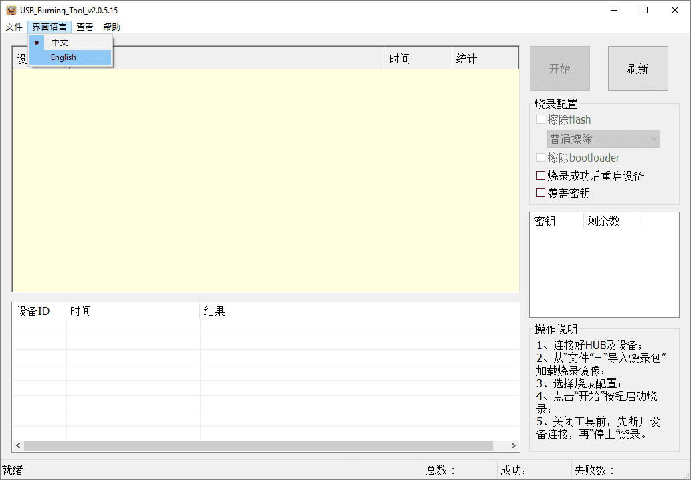
5. Open firmware file (File-Import Image) and press start.
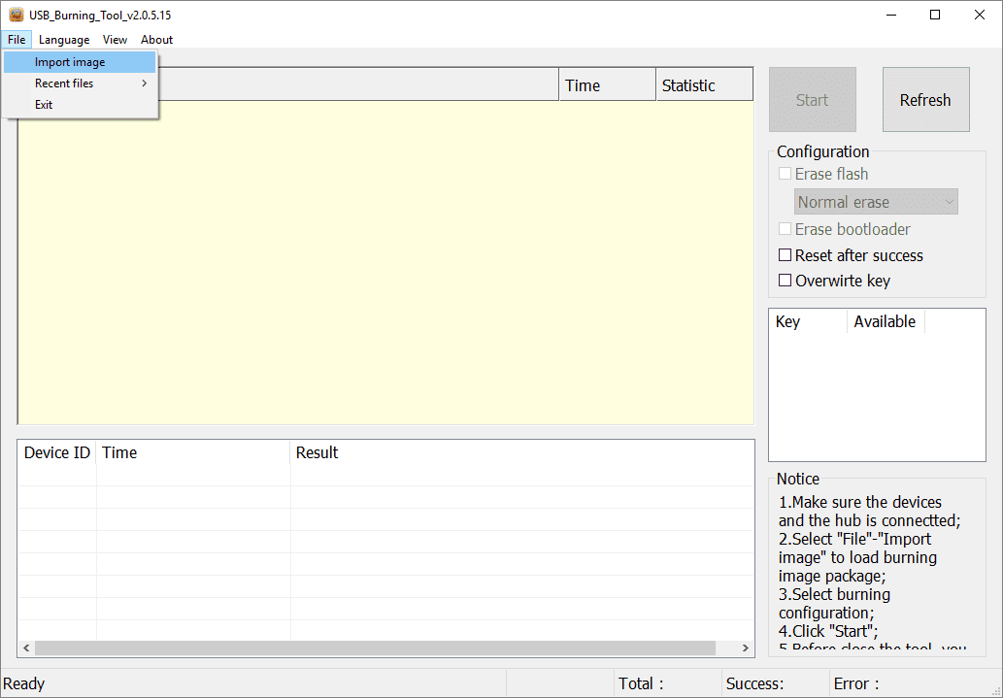
6. Connect device to PC via otg usb using usb A type cable. Device turns on automatically.
7. When PC detects device, reflashing starts automatically. If it has not happened, you should check amlogic drivers in device manager and repeat it’s installing.
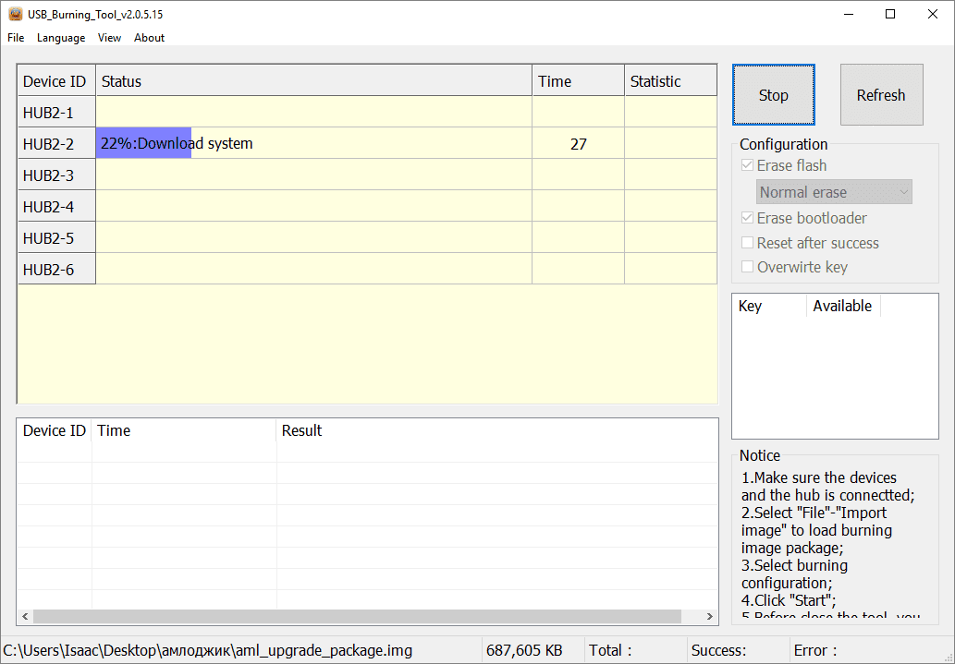
8. After reflashing device you should see “result: burning successful” message and disconnect device from host PC
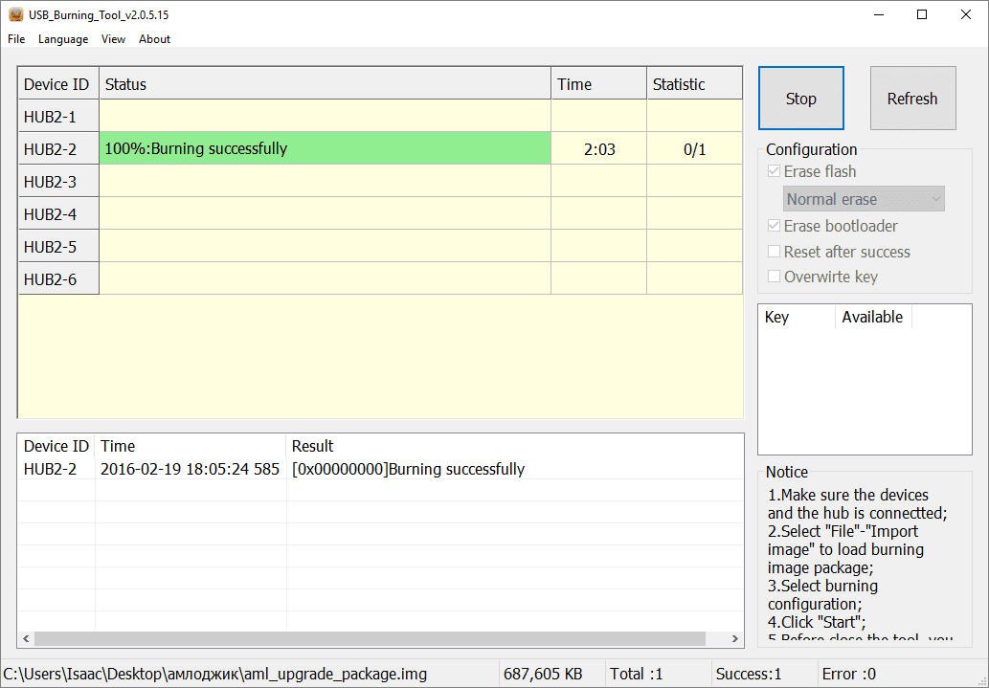
9. Disconnect device from host PC.
Reflashing firmware from recovery menu:
1. Insert usb flash drive with OTA update package in Box
2. Hold recovery button and turn on the device
3. In recovery menu choose option “update from ext”
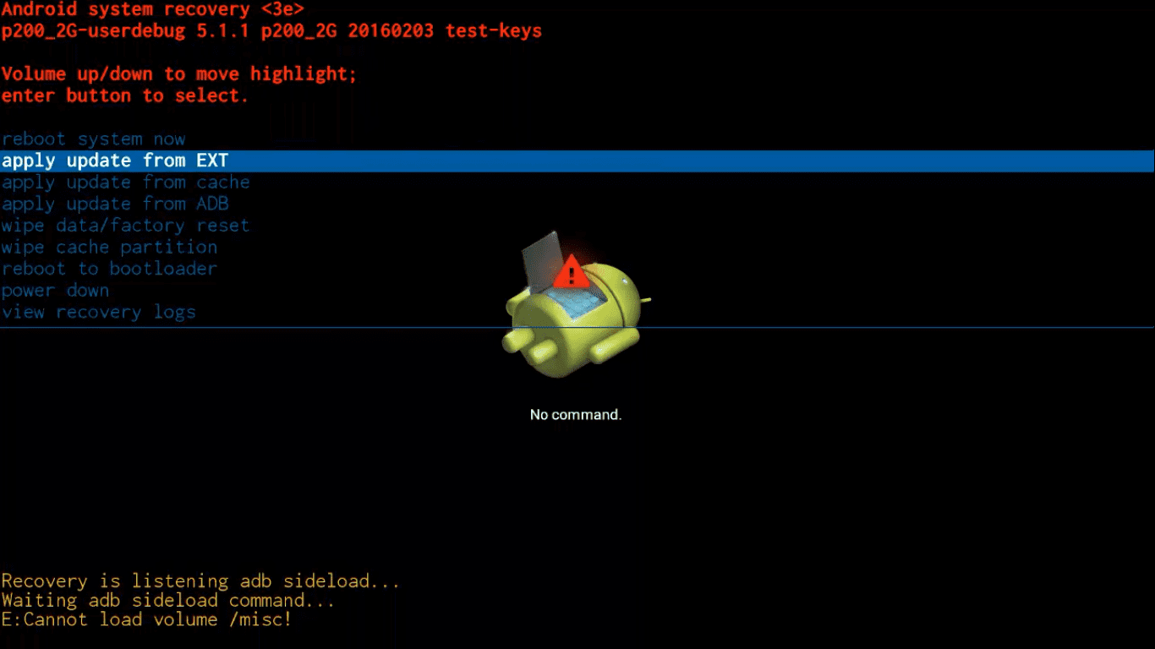
4. System let you choose sd card or usb drive. You should choose udisk.
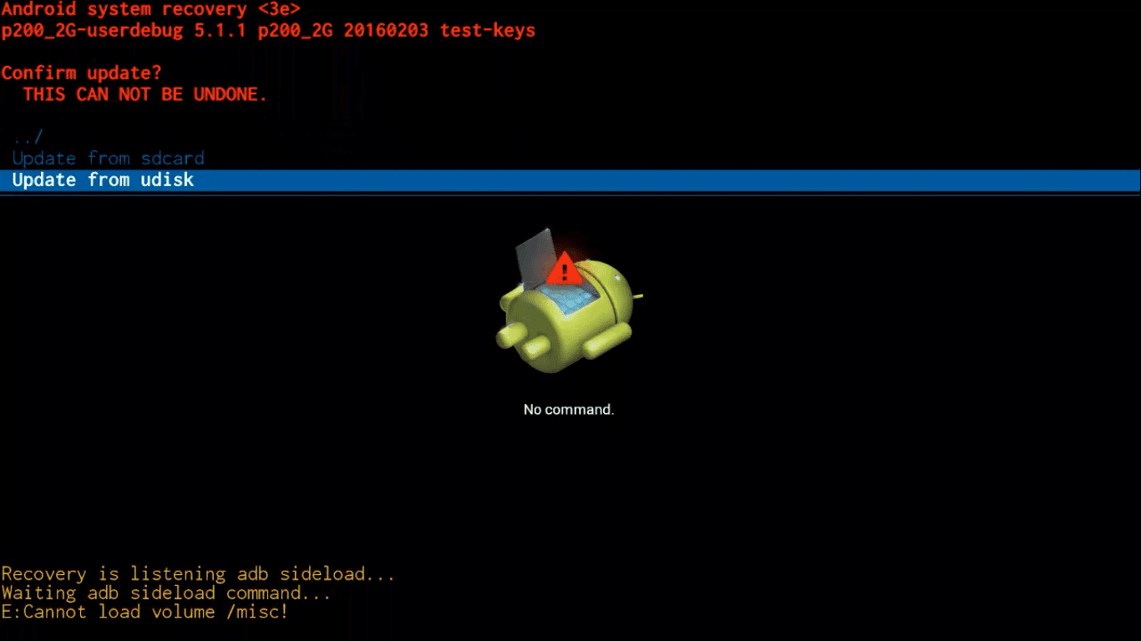
5. Then you choose update zip file previously downloaded on usb drive and system start uploading, checking and installing firmware.
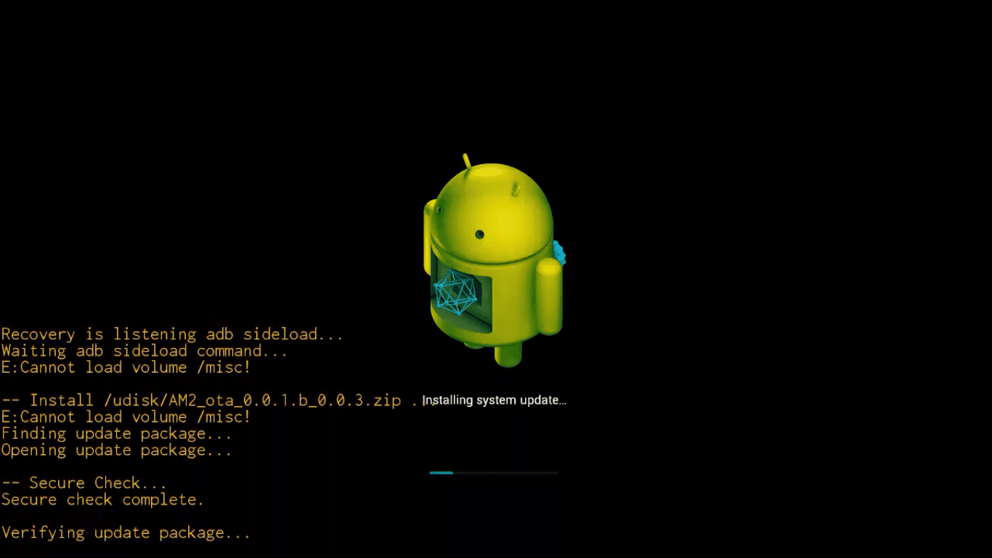
If you suddenly (!!!!) bricked your device:
The easiest way to solve this, without need of short circuit of the NAND pins, is to use Amlogic Bootcard Maker to make a bootable micro SD card with your device stock firmware.
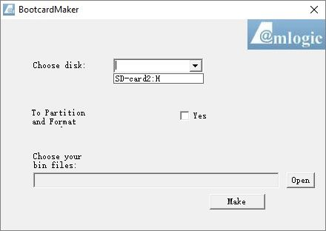
Just upload firmware image on (Micro) SD Card and put it in your device
You will be able to enter into recovery and the firmware will be flashed automatically. When the TV BOX reboots, remove the micro SD Card, this step is very important, wait 4-5 minutes and the update will completed.
Thanks for materials and answering questions to Ugoos Blog and ChinaGadgetReviews

